Wimborne Community Theatre presents

Timeless
Stream
An original celebration
of the River Allen
on the riverbank
at Walford Mill

October 21, 22, 23 • 6 pm

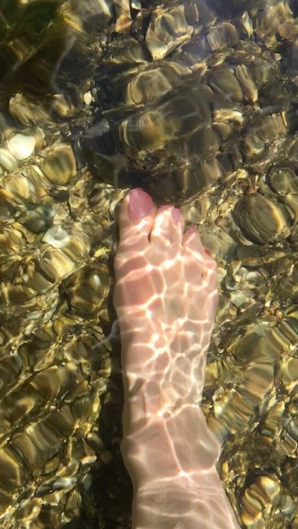

The River Allen is one of Europe’s finest chalk streams. Timeless Stream is WCT’s celebration of the beauty and diversity of creatures and organisms living on and in the river, and how interconnected we all are.
Over the last two years WCT members have researched ideas and stories about Wimborne’s rivers, Stour and Allen. During lockdown members made videos and wrote poems about living near the rivers. Students from Allenbourn School also shared memories and thoughts, as have many other local people. You can hear some in the audio-visual installation in Walford Mill and read them on WCT’s website.
Timeless Stream and other River Allen events held this week at Walford Mill during Wimborne’s Green Festival, form the first part of WCTs River project, a way of celebrating our local fauna and flora, raising key questions about how we manage our common environment. ‘Thinking globally, acting locally’. We plan to send the script, photographs and audience responses to the organisers of COP26 in Glasgow next month.
The second part of our Rivers Project will focus on and take place on and beside the River Stour next Spring. We hope to involve local people of all ages.
With funding from Dorset Community Foundation’s Dorset Performing Arts Grant we will develop a site-specific community theatre production reflecting on what the river means in our lives today, and the importance of the river ecology.
WCT celebrates thirty years producing site-specific plays in East Dorset, particularly in Wimborne. We are excited that Joe Hancock, of Burn The Curtain, will be guest director for next year’s production.

CAST
Jeff Hart Lutra Lutra, Otter
Barbara Hart/Tuppy Hill Anguila, Eel
Mark Mitchell Cottidae, Bullhead fish
Jackie May Alcedina, Kingfisher
Jane Skellett Ranunculus, Water Crowfoot (Plant)
Stuart Glossop/Katherine Courtauld Tricoptera, Caddis Fly
Dave Evans/ Clare Small Austropotamobious Pallipes, Native White-Clawed Crayfish
Tony Horitz Convenor
Dave Arkell Place Namer

CREATIVE TEAM
Gill Horitz, Tony Horitz Script from Cast research & Improvisations
Nichola Christie Compositions and Live Music
Clare Small Creature Lanterns
Heidi Steller, Clare Small & workshop participants
White Clawed Crayfish Lantern
Adrian Newton River Recordings
Tony Horitz Director
Hannah Dinmore Assistant Director
Mark Mitchell Light Structure
Production & Back stage: Tuppy Hill, Barbara Hart, Jeff Hart, Tracie Billington-Beardsley, Clare Small, Sue Bullen, Stewart Bullen, Jean Austreng, Frank Dowdle, Gill Horitz, Ashley Rowlands, Lyn Rowlands, David Small, Viv Arkell

With thanks to Terry Wheeler, Maddy Bowers at Walford Mill; Jack for loan of gazebo; Matt Renaut of Dacombes of Wimborne for equipment loan; Alastair Nisbet for Video; Dorset Council for funding; Happyccino;
If you would like to get involved or share your river memories/ideas contact: https://www.wimbornecommunitytheatre.co.uk/river-memories-local-people/
